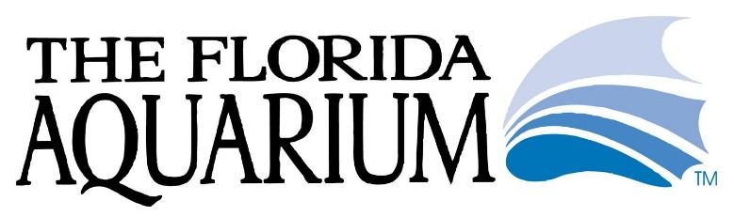
PRESENTS:
CORAL SCHOOL
May 12 – 13, 2018

Come learn everything you need to know about coral biology including advanced husbandry techniques, tricks of the trade, and how we are able to ‘farm’ coral

Target audience includes professional biologists with at least 1 – 3 years of general experience and an interest in coral husbandry

Applications and statement of institutional support due 2/1/18

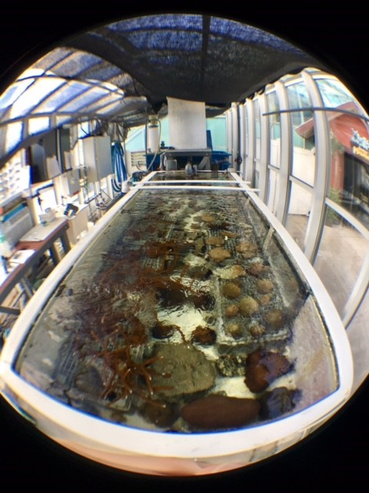

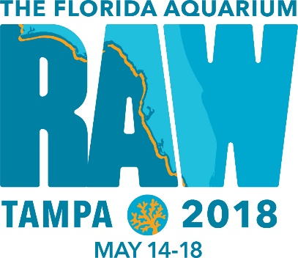

Thank you for your interest in attending Coral School on May 12 – 13, 2018.
Our goal is to create a learning experience through lecture and hands-on wetlabs for public aquarium biologists with an interest in coral biology and care.

Please email your completed application to FLAQCoralSchool@flaquarium.org

Name:
Title:
Institution:
Contact Information:

Please summarize your current role as a biologist at your home institution:

Describe your institution’s current coral collection in detail.

Have you cared for corals in the past? To what extent?

What do you hope to achieve by attending Coral School?

What are your institution’s future goals for it’s coral collection?

Does your institution support your desire to attend Coral School? Who will be covering the financial costs if you are selected?

