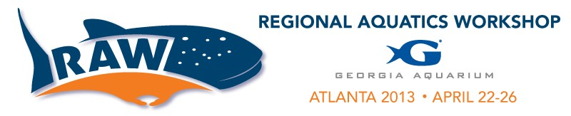

_____Poster _____Presentation

Name: Institution: Phone: Email:
Topic Category (circle all that might apply):

Crustacean Health: Issues and Solutions
Water Quality/Life Support
Propagation
Husbandry Technique/Innovation/Care Conservation/Education/Research Enrichment/Training
Quarantine/Disease Treatment/Drug Sensitivity/Acclimation Miscellaneous (Please Describe):

Presentation/Poster Title:

Abstract (300 words maximum):

ABSTRACT SUBMISSION

Please send submission to RAW@georgiaaquarium.org with "Abstract" in subject line.

Deadline March 1st, 2013.

